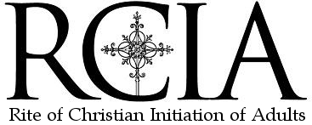  Our community is a sanctuary for the human spirit where all members may know that they can take part, their opinions are respected, efforts are made to understand differences and personal and spiritual development is fostered.  Should you like to begin journeying with us in faith, please complete the following form and mail it to the address below.  Name: ______________________________________________________________  Address:___________________________________________________________________________________________________________________________________________________________________________________________________________  Phone number: _____________________________________________________  Or if you know someone who might, please pass this leaflet on to them, or invite them to contact:  120 First Avenue  Toronto, ON.  M4M 1X1  Tel: (416) 466-2127 • www.stanntoronto.ca  Email: stannparishtoronto@gmail.com  Served by the Holy Cross Fathrers |  |  | Rite of Chirstian Initiation for Adults Program  I Period of Evangelization or Inquiry:  Saturdays: 6:30 pm to 8:00 pm  September: Registration and Interviews  Saturdays: 6:30 pm to 8:00 pm  October: My journey of life  03: Catholic Life  10: Catholic Bible  17: Catholic Church  24: Catholic Faith  II Period of Catechumenate  November, 2015 - Sacraments  07 : Initiation -Baptism, Eucharist, Confirmation  14: Healing – Reconciliation and Anointing  21: Life – Marriage and Holy Orders  28: Celebration  December, 2015 – Trinity  5: - God, the Father  12: God, the Son  19: God, the Holy Spirit  25: Incarnation – Christmas  January, 2016 – Catholic Teaching  9: History of Christianity  16: History of Eucharist  23: Catholic Moral life  30: Social Justice  III Rite of Election  February, 2016 – Creed and Prayer  6 : Catholic Creed  20: Saints and Mary  27: Catholic Prayer  March, 2016 – Lenten CALL!  05: Lent – Way of the Cross  12: Three Scrutinies  19: The Lord’s Passion Week  24: The Holy Thursday  25: Good Friday  26: Easter Vigil  IV Mystagogia  April, 03: Divine Mercy Sunday  May, 15: Pentecost Sunday  June, 22: Trinity Sunday  Served by the Holy Cross Fathrers  Contact Us  120 First Avenue  Toronto, ON.  M4M 1X1  Tel: (416) 466-2127  www.stanntoronto.ca | Contact |  | 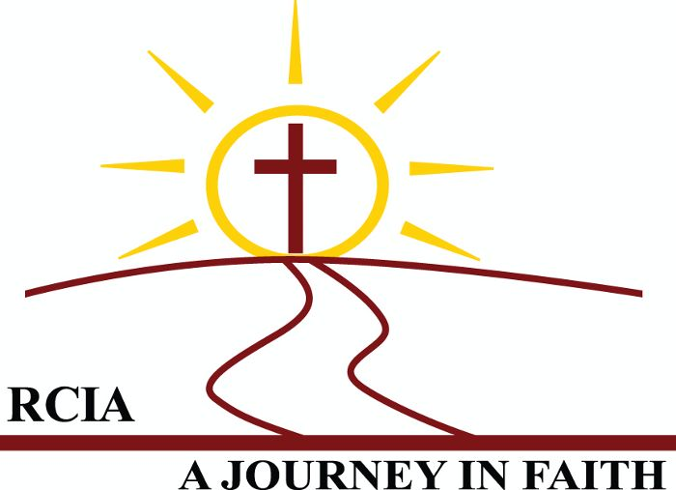  Rite of Christian Initiation of Adults (R.C.I.A.)  St. Ann Parish  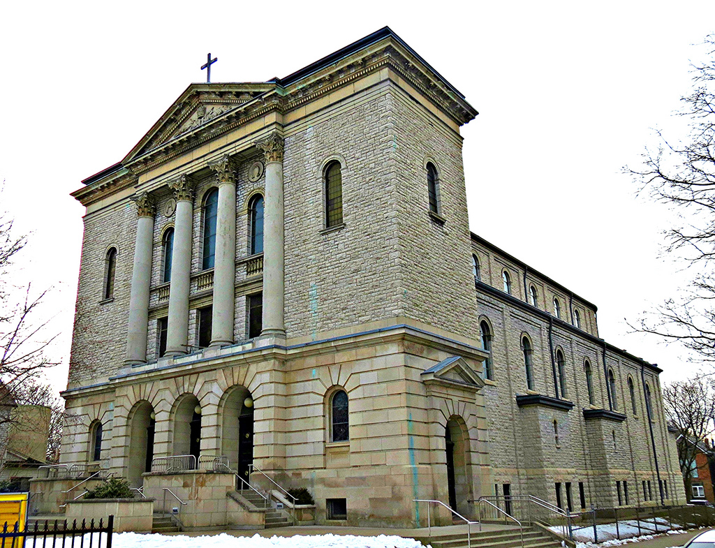  120 First Avenue. Toronto, ON. M4M 1X1  Tel: (416) 466-2127 • www.stanntoronto.ca  Email: stannparishtoronto@gmail.com
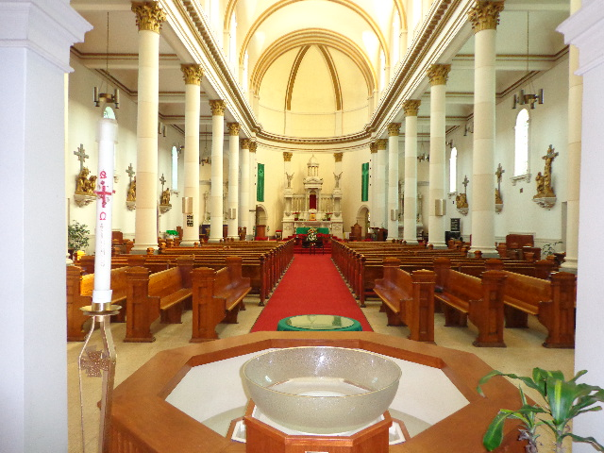  Parish Services  Matrimony: Couple contacts office one year in advance.  Baptism: Parents contact office: preparation required  Reconciliation: Saturdays 4:15-4:45 p.m. or by appointment.  Anointing of the Sick: whenever needed.  Holy Eucharist  Monday - Thursday 8:00 a.m. Friday 7:00 p.m.  Saturday Virgil 5:00 p.m.  Sunday 10:30 a.m. & 6:00 p.m.  Native Peoples’ 12:30 p.m.  Bridgepoint Hospital 2:30 p.m.  Sundays  10:00 a.m. Divine Mercy Devotion and Rosary  10:30 a.m. Pre-School and Children’s Liturgy  12:00 p.m. Holy Cross Youth Group  3:00 p.m. Handmaids of the Lord  Saturdays  8:00-9:00 a.m. Tai Chi Group  10:00-11:30 a.m. Food Bank  4:15 p.m. Novena to St. Bro. Andre  4:30 p.m. Novena to St. Ann  6:00 p.m. Healing Service (1st Saturdays)  6:00-8:00 p.m. Holy Family Prayer Group |  |  | RCIA PROGRAM – A call to be a Catholic?  Period of Evangelization  It is a period of evangelization where a candidate inquires about faith. There is no fixed time as we explore our life journey by responding to God’s call. We listen to the word of God (Bible), participate in the community (Church) and personal discernment (Faith). This journey is completed with the Rite of Acceptance into the order of Catechumens.  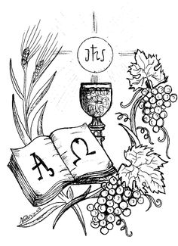  Period of Catechumenate  This is a period of personal faith formation and guidance. The catechesis tells the church’s great story of Salvation in God. Here the candidate is called to celebrate the liturgy of the Word. This period is completed when the candidate is accepted into the Rite of Election.  Period of Purification and Enlightenment  This period embraces the Season of Lent and a time of intense spiritual preparation for the sacrament of Initiation. It is a time of retreat and reflection. Here the community invites the elect to join them in the Lenten journey as they prepare for the Lord’s Passion. Through the process of three scrutinies, the elect makes public his/her desire while the community supports them with examples and prayers. This period is completed with the elect receiving the sacrament of initiation during the Easter Vigil. This is the crowning point for a Christian as the community welcomes and celebrates new life in the Church.  Period of Postbaptismal Catechesis or Mystagogy  After the baptism the life of the Christian begins into following Christ life. It is a lifelong journey with Christ in the church, by not just learning but living a Christian life. |  |  | About Us  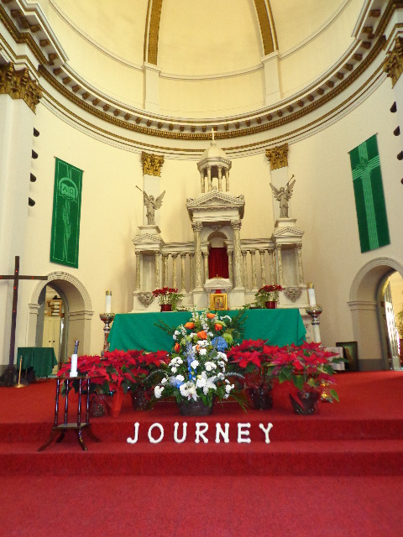  Stablished in 1914, St. Ann Roman Catholic Parish is a communion of small communities within God’s people representing all ages, races, cultures, and states of health and mind. As sisters and brothers, we work together and value one another in our diversity. As a servant community, we are committed to answer the needs of our parishioners, our neighborhood and our city. Challenged by the world, we are called to be in solidarity with suffering people everywhere, and to work and act together for fullness of life through compassion and justice as God’s hands in the world.  SERVICE TO THE SOCIETY  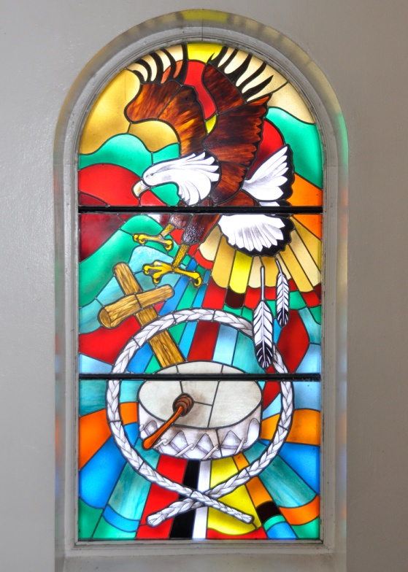  In the Archdiocese of Toronto, St. Ann’s Church is the Home Parish for the Aboriginal Peoples of Canada. Our West side chapel is dedicated to St. Kateri Tekakwitha, the first Canadian native saint. She was canonized in 2012. St. Ann parish is the only place in Toronto, where the Mass is celebrated for the Native People of Canada.  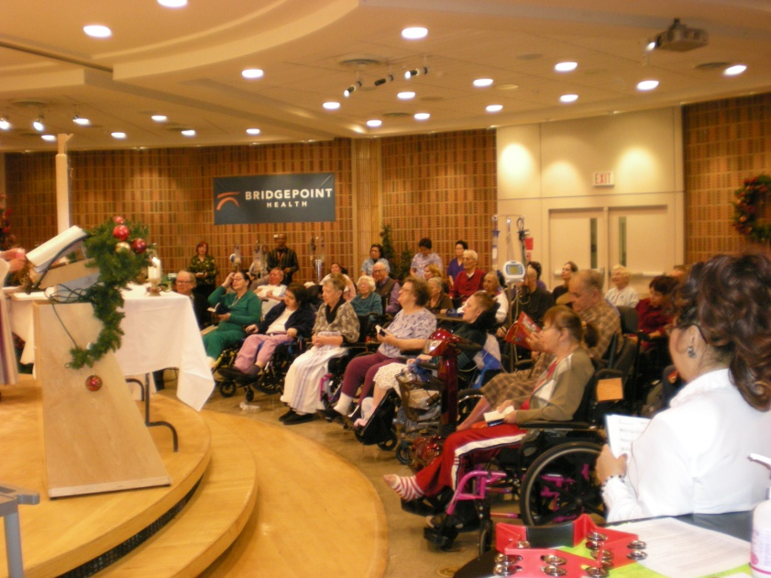  For more than 30 years, St. Ann’s Parish has ensured that patients at nearby Bridgepoint Active Healthcare receive pastoral care and attend Mass.  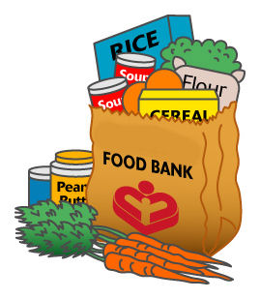  St. Ann’s is the only Catholic parish that serves 120 individual and family members per week at St. Ann Food Bank. The Development and Peace group of St. Ann’s are actively involved at local and global justice issues.

