**Mass Intentions**

**(June 8 – June 15, 2018)**

**Friday, June 8:** 7:00 p.m. Mass

*Solemnity of the Most Sacred Heart of Jesus*

**Intentions of the Congregation of Holy Cross**

**+ Souls of the faithful departed** *Req. Van Hoang*

**Monday, June 11:** 8:00 a.m. Mass

**Thanksgiving for Alexia Dunn** *Req. Toro Young Family*

**+ Maria Borges** *Req. Vieira & Costo Family*

*The Tabernacle Vigil Light will be lit this week for the soul of Aurelia Nobleza*

**Year of Ministry – June 2018**

During the month of June, we pray for all the men who minister in the Church. We pray and support them in their various ministries in our parish community. We also remember and pray for all the fathers who work hard to build up and provide for their families. We also support and pray for our Refugee Resettlement Group and Pastoral and Finance Council. Thank you for your time, talents and effective ministry at St. Ann parish and Native Peoples’ Mission. May God continue to bless you.

**ShareLife 2018**

**Living the Gospel by helping youth rebuild their lives.** Sarah couldn’t get along with her mother, so she tried living on the streets at age 14. She hitchhiked to Toronto to move in with her cousin, who soon kicked her out. Having no place to go, Sarah decided to try Sancta Maria House. She initially hated the structure and rules. However, the supportive staff won her trust and helped her return to school. At the end of her stay, she restored her relationship with her mother. ShareLife-funded agencies like Sancta Maria House are helping at-risk youth turn their lives around. **Please consider making a sacrificial gift to ShareLife through your parish or at sharelife.org.**

**Thank you for your generosity.**

**Mother of Perpetual Help Novena Triduum**

Join St. Patrick’s Church (131 McCaul St.) for the annual Novena Triduum at the Shrine of Our Lady of Perpetual Help from **June 25-27.** They will welcome Bishop Robert Kasun CSB and Fr. Mark Miller CSsR as presiders and preachers, each evening beginning at 7:00 p.m.

Consists of Novena Prayers, Mass and Mission Homily. For more information and complete schedule, please visit www.stpatrickstoronto.ca

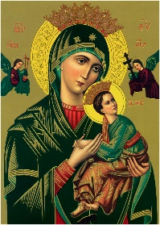

**Thank you!**

A heartfelt thank you to the Handmaids of the Lord, Choir and all who contributed towards the Dinner and Dance on June 9. We are thankful for your continuous ministry at St. Ann’s and Native Peoples’ Mission. Proceeds of the event will go towards the feast day celebrations on Sunday, July 29

**Handmaids of the Lord Father’s day Breakfast**

The Handmaids of the Lord will be hosting their last Sunday Breakfast before the summer break **Next** **Sunday,**

**June 17, to celebrate Father’s Day.** Please join us at the hall after the 10:30 a.m. mass for freshly made breakfast and fellowship with the community.

[](https://www.google.ca/url?sa=i&rct=j&q=&esrc=s&source=images&cd=&cad=rja&uact=8&ved=0ahUKEwjF1r3RzbXZAhXGz4MKHeBGAQcQjRwIBw&url=https://depositphotos.com/12427393/stock-illustration-plate-knife-and-fork.html&psig=AOvVaw2ZYPk4LgNZF9q03wYTRBj8&ust=1519254342358001)

**Marygrove Girls Camp Collection**

This weekend, **June 10,** there will be a special collection for Marygrove Girls Camp, run by the Society of St. Vincent de Paul. Each year, over 1,000 young girls with financial or domestic hardship enjoy a subsidized joyful camping experience. Please give generously.

**Summer Schedule Bulletins**

As we commence the summer time, St. Ann’s Parish Bulletin will circulate twice a month. Dates for publication during this time are June 17th, July 1st, 15th & 29th, August 12th & 26th and September 9th.

**Post-Secondary Campus Ministry**

Attention high school graduates: Are you moving on to post-secondary education in the fall? Check out Campus Ministry! Connect to campus ministry by visiting www.chaplaincyconnect.ca and find your Catholic home on campus. For information about the campus ministries in our archdiocese, please view the poster at our parish bulletin board or at http://bit.ly/PostSecondaryCampusMinistry.

**What is original sin?**

You won’t find the phrase “original sin” in the Bible. The story of humanity’s “fall” in Genesis 1 doesn’t use the term, and St. Paul, one of the church’s earliest theologians, only hints at it in places. After the first century the early church fathers started to define it, but those in the East and West took different approaches.

Both groups acknowledged that sin had entered the world through Adam and Eve’s disobedience to God’s command, but the Eastern fathers did not think guilt for that sin was passed on; rather, human beings in subsequent generations imitated their first ancestors’ misbehavior. The Western fathers, however, believed sin was passed on like a hereditary disease of the soul (thus the emphasis on baptism

erasing the inherited “contagion of death,” to use St. Cyprian of Carthage’s phrase).

Saints Irenaeus and Augustine illustrate these two perspectives. For Irenaeus the disobedience of the first parents was rather like the actions of a child who didn’t know better. Augustine, however, thought the first sin had resulted from a very conscious, adult decision that actually damaged human nature and was passed on through procreation.

But a question remained: Why did the possibility of sin enter the world in the first place? Irenaeus thought the turning away of Adam and Eve from God resulted from their immaturity and weakness. Augustine saw the source in a fatal flaw in human nature: pride. For him pride meant the capacity to exercise free will to choose to try to live without God—to see yourself only in reference to yourself, not to God, and to have a sense of false autonomy that you forget you are created.

Through the Middle Ages and after the Reformation, Catholic theology began to emphasize another aspect of the doctrine of original sin: the absence of “sanctifying grace,” the indwelling spirit that brought the inner harmony and holiness that Adam and Eve had before the fall.

Most of those explanations were based in part on a literal reading of the story of the fall. Very few people today other than fundamentalists and creationists believe in an actual first couple named Adam and Eve who physically bequeathed their sin to the human race. But you don’t have to look very long at the human condition to see the continuing relevance of the idea of original sin. The presence of so much violence, selfishness, corruption, stupidity, and cruelty in the world points to the fact that Augustinian “pride” is still alive and kicking, and it is evidence that indeed something at some point seems to have gone seriously wrong with human nature.

The Christian answer to original sin, however, has always been redemption and salvation: the ongoing possibility that human beings, through Christ, can open themselves to goodness and love and restore their relationships with God and one another.

Author:[*Joel Schorn*](http://www.uscatholic.org/authors/joel-schorn)*. This article appeared in the*[*January 2013*](http://www.uscatholic.org/january2013)*issue of*U.S. Catholic*(Vol. 78, No. 1, page 54).*

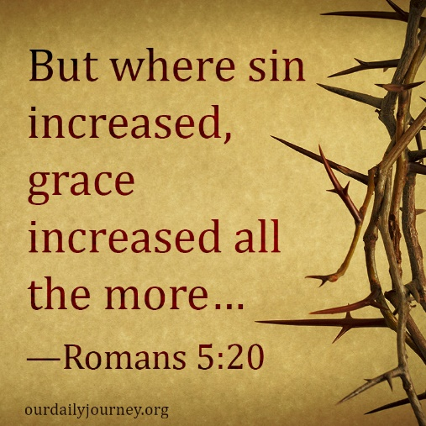

**Pilgrimage to Quebec Shrines - 4 Days, 3 Nights**

Holy Cross Family Ministries invites you to join us on a Pilgrimage to Quebec Shrines from **August 3-6.** Visit St. Anne de Beaupre, Cap de Madeleine, St. Joseph Oratory and Quebec City, with time for personal prayer and spiritual activities. Departure from St. Ann Church on Friday, August 3 at 7:00 a.m. Price: $500.00 pp (includes travel and lodging). Pilgrims are responsible for meals, out of province insurance, spending money and personal belongings. A non-refundable deposit of $150.00 is required by July 1st. For more information, please contact Maria Fernandes at 416 469 5277 or the parish office at 416 466 2127.