**Year of Ministry – April 2018**

During the month of April, as we celebrate the resurrection of Jesus Christ, who invites us to proclaim the Good News of our Salvation, we pray and support our **Ministers of the Word** (Lectors), the Ministers of **Holy Communion**, **Ushers** and the Ministers of the **Hospitality**.

If you would like to be part of any of these ministries, I ask you connect the office or fill out the form available at the entrance. I also encourage those who serving in these ministries to attend an information session on **Accessibility for Ontarians with Disabilities Act to be held on April 29th, 2018 Sunday after the morning 10:30 am mass**. Thank you for your time, talents and effective ministry at St. Ann parish and Native Peoples’ Mission. May God continue to bless you.

**Mass Intentions**

**(April 27– May 4, 2018)**

**Saturday, April 28:** 5:00 p.m. Mass

**+Pushpam George** *Req. Shibu Kannampuzha*

**Sunday, April 29:** 6:00 p.m. Mass

**Thanksgiving for Florie Salvatierra** *Req. Florie Salvatierra*

**+ Liberty Agagas** *Req. Rosalie Tolentino*

**Monday, April 30:** 8:00 a.m. Mass

**+Tai Yu Lee** *Req. Hugh and Connie Lee*

**ShareLife 2018**

**Living the Gospel by helping newcomers to Canada.** Angie moved to Canada to marry a man she met online. He was not who he seemed; she endured emotional and physical abuse. While he was at work, she started attending language classes at Catholic Crosscultural Services. Staff at CCS connected her with a settlement worker in the women’s program. Angie received the support she needed to exit her violent relationship and live independently, free from abuse. Angie is one of over 3,000 clients helped annually by CCS programs funded by ShareLife.

**May 27 is the next ShareLife Sunday.**

**Please give generously.**

**Archdiocesan Day of Prayer: May 4**

The Archdiocesan Day of Prayer will be celebrated on May 4. We invite you to support and to pray for all vocations; priesthood, religious and

consecrated life. For more information, please contact or call the office of Vocations at vocations@archtoronto.org.



**Catholic Education Week: May 6-11**

We invite all parishioners to join in celebrating Catholic Education Week 2018, which runs from May 6-11. For more than 165 years, Ontario’s publicly funded Catholic schools have been integrating our faith into all aspects of school life, nurturing the gifts and talents of every student. We celebrate the distinctive contribution that Catholic schools provide, giving thanks and offering our prayers for all those who faithfully journey with our young people each day. To affirm your support of Catholic Education and sign up for email updates, visit: www.togetherinfaith.ca

**Free Screening of *After the Storm: Building the Pope Francis Village***

Development and Peace invites you to a free screening of the film *After the Storm: Building the Pope Francis Village* on **April 29**. Screening of the film takes place **at Lynch Hall, Our Lady of Lourdes Church at 3 p.m.** This film documents the rebuilding efforts in the Philippines following the 2013 typhoon and the ground efforts of Development & Peace in response to the crisis. All are welcome!

**Society of Sharing Inner-city Volunteers**

They are a ShareLife member agency asking the community to join them for *A Friendly Walk And Run* on **Sunday June 10, 2018**. This is a timed 5K Run, 5K Walk and 1K Walk, through downtown Toronto. The event will help raise awareness and money for struggling seniors and adults with physical disabilities living under the poverty line in the GTA. For more information, to donate or volunteers with The Society, please call 416-413-0380 or read the bulletin board flyer for other ways to get involved.

**Church Bulletin Advertising**

Liturgical Publications will be setting up the advertisements for our church bulletin. The advertising will begin in July 2018 and supports the bulletin service. Please support the bulletin and advertise your product or service. Call Liturgical Publications at 905-624-4422.

**I am the True Vine**

**Reflections by Rev. Wilson Andrade**

Today let us reflect on this beautiful Gospel where Jesus proclaims: “I am the True Vine,” and invites each one of us to “remain in Him,” so that together we can “bear much fruit.” The Scriptures invite us to reflect on our relationship with God and the fruitfulness of our relationship in the Christian community.

**Vine:** “*I am the True Vine.*” Jesus reminds us that God is the source of all energy in creation. He is the creator. In the Gospel of John we read about the famous “I am” statement of Jesus. This statement makes a reference to the Divine name “I am who I am” in Exodus 3:14. Jesus refers to himself as the True Vine, revealing his close relationship with the Father as the “vine grower.” The Holy Spirit abides in the love between the Father and the Son. Here we can reflect on the Trinitarian relationship between the Father, the Son and the Spirit. What is my image of God, who is love?

**Branches:** *“I am the vine, you are the branches. Remain in me as I remain in you.”* This statement brings to our awareness the unique relationship between God and the People of God. In nature we know of the amazing process where plants derive nutrients from the earth, from the stem to the branches to the leaves and flowers and fruit. This example from nature could help us in our inner spiritual relationship with God. We need to abide in God so that we become energized to carry out our daily tasks in life. This energy of love comes from God, is supposed to be mutual. God’s love is not demanded or forced on others. Love is not possessing or being possessed by someone. It is a relationship to experience the depth of grace and God’s energy with one another. How is my relationship with God?

**Fruit:** *“Whoever remains in me and I in him will bear much fruit.”* Nature teaches us that any fruitfulness is a result of communal effort. It is not an individual endeavour, not the least attainable alone. We can also observe that without the flow of this energy within the vine the branches dry out. Love brings about life and fruitfulness. Our relationship with God could be witnessed in the way we live our daily life: in our behaviour, our words, our attitudes, and our actions. How can I bear much fruit in God?

As the healthy vine gives good fruits, a healthy community rooted in Christ will help to build authentic relationships expressed in love, forgiveness, joy and peace. St. John invites all of us: “let us love not in word or speech but in deed and truth.” (1 John 3:18) The Acts of the Apostles gives an account of the First Church that grew in numbers led by the Holy Spirit and was at peace. (Acts. 9: 31) Even in the modern world, like the First Christians, we can bear much fruit if we remain in Christ, the true vine.

[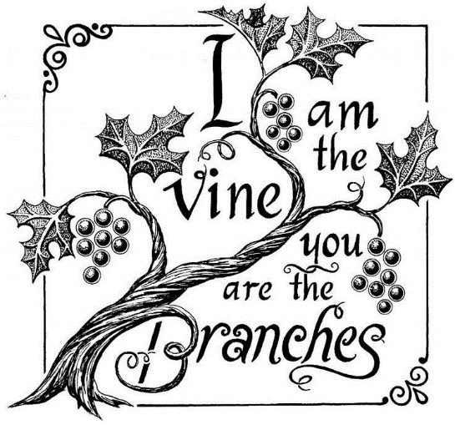](https://www.google.ca/url?sa=i&rct=j&q=&esrc=s&source=images&cd=&cad=rja&uact=8&ved=2ahUKEwiX1-imydXaAhXry4MKHe3DCT0QjRx6BAgAEAU&url=https://www.pinterest.com/pin/405886985147365023/&psig=AOvVaw1WJ9AMI9aMApUTsH3VHn9y&ust=1524750736923088)

[](https://www.google.ca/url?sa=i&rct=j&q=&esrc=s&source=images&cd=&cad=rja&uact=8&ved=0ahUKEwjF1r3RzbXZAhXGz4MKHeBGAQcQjRwIBw&url=https://depositphotos.com/12427393/stock-illustration-plate-knife-and-fork.html&psig=AOvVaw2ZYPk4LgNZF9q03wYTRBj8&ust=1519254342358001)

**Holy Cross Family Ministries: Celebrating Family Prayer**

*“Family that Prays together, stays together.” -* Ven. Patrick Peyton, CSC

Join us to celebrate Family Prayer on **Saturday, May 5,** **2018** hosted by the Holy Cross Family Ministries.

**4:00 p.m.** – **Marian Procession and Rosary**

**5:00 p.m**. - **Holy Eucharist** celebrated by Archbishop James MacDonald, CSC

**6:00 p.m.** - **Dinner & Dance**

Dinner and Dance Tickets are available at $15.00 at the back of the church. Proceeds will go towards supporting the Holy Cross Family Ministries in Canada. Please, continue to support as begin the Family ministry in Canada.

**Handmaids of the Lord Sunday Breakfast**

Join us **today Sunday, April 29**, for the Handmaids of the Lord monthly Sunday Breakfast Please come down to the hall after the 10:30 a.m. mass and join us for a freshly made breakfast and fellowship.