**Mass Intentions**

**(August 24 – September 7, 2018)**

**Saturday, August 25:** 5:00 p.m. Mass

**+ Pushpam George** *Req. Shibu Kannampuzha*

**Sunday, August 26:** 6:00 p.m. Mass

**+ Rodolfo Salvatierra** *Req. Florie Salvatierra*

**Year of Ministry – August 2018**

During the month of August, we dedicate it to and pray for Bridgepoint Hospital Ministry, Collection Counters and Pilgrimage ministries at our parish community. We pray, support them and thank volunteers involved in these ministries for your time, talents and effective ministry at St. Ann parish and Native Peoples’ Mission. May God continue to bless you.

**Prayer and Life Workshops Sign up**

**This Saturday, August 25**, we commence the *Prayer and Life Workshops.* Nadine Lubin will be guiding these workshops that will take place on Saturday evenings at 6:00 p.m. She will be available after mass for anyone who may have questions or be interested in participating in the workshops.

**Parliament of World Religions**

Toronto will host the Parliament of the World’s Religions, this **November 1-7, 2018**, at the Metro Toronto Convention Centre. There will be a number of Catholic events among the more than 500 programs, workshops and dialogues scheduled throughout the week, including a presentation by Cardinal Collins, Jesuit scientist Fr. Rob Allore, and a performance from St. Michael’s Choir School. There will also be music, dance, art and photography exhibitions presented by the world’s religious communities and cultural institutions. Parishioners are encouraged to participate in this important interfaith event by registering, either as a group or as individuals, for one or more days of the Parliament. There are group rates, student rates and specific programs for children under 12. Day passes are also available and you can get a 20% discount on registration with promo code: C2C2C. Please visit https://www.parliamentofreligions.org/parliament/2018-toronto for more information.

**2018 Parish Ministry Conference**

The Office of Formation for Discipleship is launching a new conference aimed at helping to inspire parish ministers to better serve their parish communities. It is called “Be Disciples. Make Disciples” and will be held on **Saturday, October 20, 2018**, 9 a.m. to 3 p.m. at St. Basil-the-Great College School, (20 Starview Lane, North York). Over 12 ministry workshops will be offered, with time for ongoing formation, personal reflection, faith sharing, fellowship, networking and the celebration of the Eucharist. The Mass celebrant and keynote speaker will be His Eminence Thomas Cardinal Collins. Registration is now open. The cost to attend is $15 per person (**early bird rate for people who register before August 31, 2018**) and $25 per person thereafter. The registration fee includes entry to the conference, lunch and light refreshments. For registration and more information please visit: www.archtoronto.org/disciples.

**Presentation from Knights of Columbus**

**Today, August 26, 2018** the directors of Knights of Columbus will do a presentation after the 10:30 a.m. Mass. I thank the Knights for their support to St. Ann Parish and to the Foodbank.

If you would like join the Knights of Columbus, please call the office and fill in the form. We ask you to support the activities of Knights of Columbus.

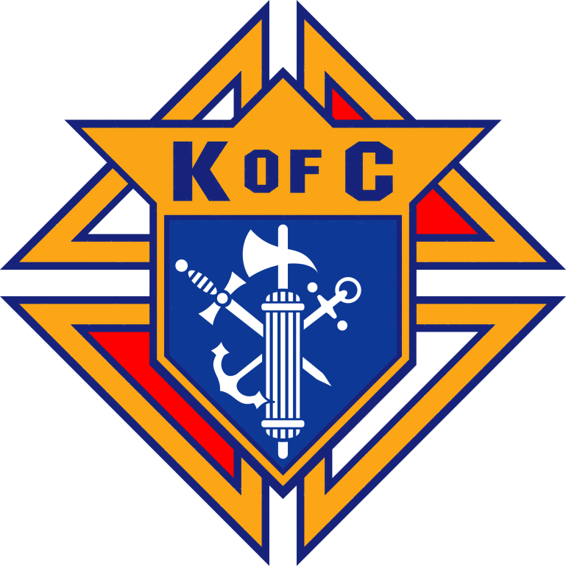

**Pilgrimage to Mexico & Ecuador**

Join us for a Pilgrimage to Mexico and Ecuador **on May 02 – May 15, 2019** with Fr. Wilson Andrade, CSC. We will visit the shrine of Our Lady of Guadalupe and many churches.

Information sheets are available at the entrance or call QS Travel and Tours at

905-412-2242 or visit [www.qstours.com](http://www.qstours.com)

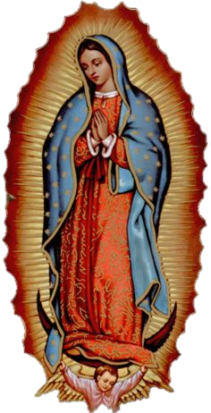

**Summer Bulletin Schedule**

As summer time comes to an end, St. Ann’s Parish Bulletin will resume regular publishing schedule on the weekend of September 9.

**Jesus: the Bread of Life**

**Reflections by Pope Francis**

In life, we constantly need to be fed: nourished not only with food, but also with plans and affection, hopes and desires. We hunger to be loved. But the most pleasing compliments, the finest gifts and the most advanced technologies are not enough; they never completely satisfy us.

“The Eucharist is simple food, like bread, yet it is the only food that satisfies, for there is no greater love. There we encounter Jesus really; we share his life and we feel his love.

Let us choose this food of life! Let us make Mass our priority! Let us rediscover Eucharistic adoration in our communities! Let us implore the grace to hunger for God, with an insatiable desire to receive what he has prepared for us.

Jesus prepares a place for us here below, because the Eucharist is the beating heart of the Church. It gives her birth and rebirth; it gathers her together and gives her strength. But the Eucharist also prepares for us a place on high, in eternity, for it is the Bread of heaven.

The Eucharist is our ‘reservation for the heavenly banquet. It is Jesus himself, as food for our journey towards eternal life and happiness. He looks for places untouched by love, untouched by hope...”

Everyone knows people who are lonely, troubled, or in need: “they are abandoned tabernacles,” Those who receive Jesus in the Eucharist, “are here to prepare a place and a meal for these, our brothers and sisters in need.”

“Jesus became bread broken for our sake; in turn, Jesus asks us to give ourselves to others, to live no longer for ourselves but for one another. In this way, we live *“eucharistically,”* pouring out upon the world the love we draw from the Lord’s flesh.

The Eucharist is not a beautiful rite, but it is the most intimate, the most concrete, the most surprising communion that one can imagine with God: a communion of love so real that it takes on the form of eating the Bread of life.

The Christian life begins again at each Mass, “where God satiates us with love. Without Jesus, the Bread of Life, every effort of the Church is vain,…works of charity are not enough, unless those works are done with charity. Christian life “must be invested in Jesus and spent for others, go out, regardless of the problems and uncertainties. We are all called, in whatever situation we find ourselves, to be bearers of paschal hope” and to be “servants of the world, but resurrected, not employed; without ever complaining, without ever resigning ourselves. It’s beautiful to be couriers of hope, simple and joyful distributors of the Easter alleluia.”

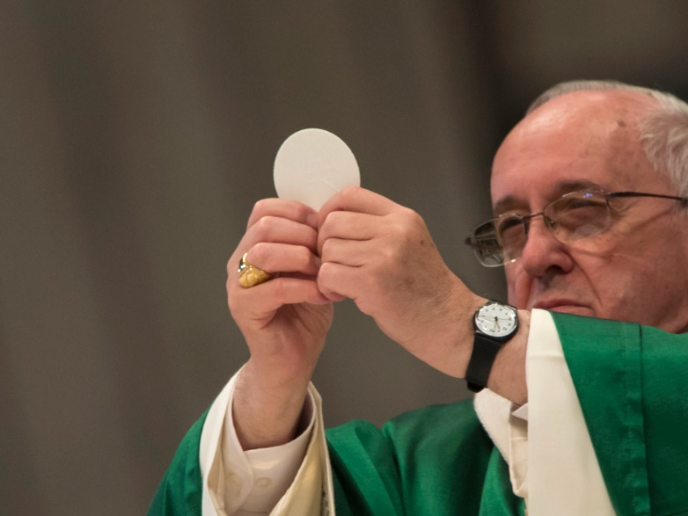

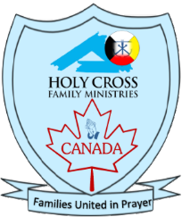

**Holy Cross Family Ministries – Canada**

On behalf of the Holy Cross Family Ministries – Canada, I would like to thank everyone who helped during the many activities we held in the month of July and August in promoting Family prayer. We also would like to thank Fr. Wilfred Raymond, CSC – President of Holy Cross Family Ministries and Fr. Pinto Paul CSC, International director of HCFM who visited our parish and supported our ministries in Canada. We continue to ask for your prayers and support for Holy Cross Family Ministries in Canada.

“A family that prays together, stays together.” – Ven. Patrick Peyton, CSC