**Holy Cross Family Ministries: Celebrating Family Prayer**

*“Family that Prays together, stays together.”*

Venerable Patrick Peyton, CSC

Join us to celebrate Family Prayer on **Saturday, May 5,** **2018** hosted by the Holy Cross Family Ministries.

**4:00 p.m.** – **Marian Procession and Rosary**

**5:00 p.m**. - **Holy Eucharist** celebrated by Archbishop James MacDonald, CSC

**6:00 p.m.** - **Dinner & Dance**

Dinner and Dance Tickets are available at $15.00 at the back of the church. Proceeds will go towards supporting the Holy Cross Family Ministries in Canada.

**Mass Intentions**

**(March 23 – March 30, 2018)**

**Friday, March 23:** 7:00 p.m. Mass

**Thanksgiving for Mary Chen** *Req. Mary Chen*

**Saturday, March 24:** 5:00 p.m. Mass

**+ Isadore Jannetta** *Req. Sr. Mary Fatta*

**+ Pushpam George** *Req. Shibu Kannampuzha*

**+ Cresenciana Gallardo** *Req. Luzviminda Gallardo*

**Sunday, March 25:** 6:00 p.m. Mass

**+ Victor Esperancilla** *Req. Rose Pilande*

**Intentions of Carmel Caruana** *Req. Agnes Caruana*

**Monday, March 26:** 8:00 a.m. Mass

**+ Devdit Fernandes** *Req. Maria Fernandes*

**Pabasan ng Bayan 2018 in Tagalog**

Join us in meditating the Passion of Christ through chanting and praying.

**Date:** Holy Thursday, March 29, 2018

**Time:** 9:00 a.m. (Holy Thursday) to

2:00 p.m. (Good Friday)

**Place:** St. Ann’s Parish Hall

For more information, please contact our

Parish office at 416-466-2127 or Fe Santos.



**Year of Ministry – March 2018**

During the month of March, please keep in your prayers and support the Food Bank and Development and Peace Group.

**St. Ann Food Bank** is celebrating their 15 year anniversary and, at present, serves 180 clients every week. Thank you for your contributions towards the food bank. For more information please contact Carlos and Collette Carreiro.

**Development and Peace** group welcomes new members to join their group raising awareness for important social justice issues.

Thank you for your time, talents and effective ministry at St. Ann parish and Native Peoples’ Mission. May God continue to bless you.

**Fish and Chips**

St. Ann Parish will be hosting the **last Fish and Chips Friday** for the season of Lent this Good Friday, **March 30**. Join us

at the parish hall after the Divine Liturgy. Suggested price: $5.00 Proceeds go towards the new Heating System project.



**Seminar on** **the Joy of Love: *Amoris Laetitia***

The Holy Family Prayer group is hosting a seminar on Pope Francis’ latest letter: ***The Joy of love Amoris Laetitia***. This is a special invitation for couples and families to register

for the Sessions held on the fourth Saturday of the month after the 5 p.m. Mass. **Our last session will be on April 28, from 6:30 - 7:30 p.m, at the Hall.** For more information please contact the parish office.

[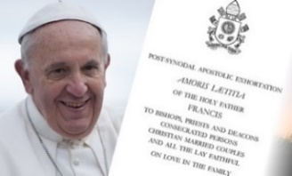](https://www.google.ca/url?sa=i&rct=j&q=&esrc=s&source=images&cd=&cad=rja&uact=8&ved=0ahUKEwj41NzI6PDYAhUp54MKHaedBKIQjRwIBw&url=http://nceatalk.org/2016/09/webinar-amoris-laetitia-listening-to-the-joys-and-hungers-of-families-part-1/&psig=AOvVaw3Iqy19Ca8fLQ9E3DFoK4SL&ust=1516890715891168)

**Holy Thursday Soup Supper & Fellowship**

We welcome everyone to bring your special Soup to share with others for **Holy Thursday;** as well as light goodies and finger food for

fellowship after the **Saturday Easter Vigil**.

[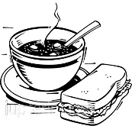](https://www.google.ca/url?sa=i&rct=j&q=&esrc=s&source=images&cd=&cad=rja&uact=8&ved=0ahUKEwif6o7PxPfSAhUG1oMKHeClB5wQjRwIBw&url=http://www.clipartvision.com/soup-and-sandwich-clipart-black-and-white/&bvm=bv.150729734,d.amc&psig=AFQjCNHr8mSZcn10h8polzuOtsgCL4l7lQ&ust=1490733339989550)

**Easter Flower Donations**

We are accepting donations for our Easter Flowers. Envelopes are available at the back of the church. Please drop it in the basket during the offertory. Thank you for your donations.

[](https://www.google.ca/url?sa=i&rct=j&q=&esrc=s&source=images&cd=&cad=rja&uact=8&ved=0ahUKEwiXgtHnxvfSAhUn6oMKHckvD0YQjRwIBw&url=https://clipartfest.com/categories/view/a2940a0ed5b952ba71381704d8172b3242b6a1ed/free-clipart-easter-flowers-black-and-white.html&bvm=bv.150729734,d.amc&psig=AFQjCNFwxiwMhnKj-zNdIUmCPvuCzq9egQ&ust=1490733932535822)

**TAX Receipts for 2017**

Please do pick up your 2017 Tax Receipts at the Main Entrance of the Church. These are from your donations made to St. Ann parish only. Donations made to Family of Faith campaign are mailed directly to you. If you have questions regarding the Tax Receipts please call the office or email us.

.

**HOLY WEEK CELEBRATIONS**

**Parish Reconciliation Service Chrism Mass at St. Michael’s Cathedral**

Sunday, **March 25** at 5:30 p.m. Tuesday, **March 27** at 11:00 a.m.

Followed by Mass at 6:00 p.m.

**March 29th: Holy Thursday**

**6:00 p.m.:** Potluck Soup Supper

**8:00 p.m.**: Holy Eucharist,

**March 30th: Good Friday** Followed by Adoration

**3:00 p.m.:** Divine Liturgy

**6:30 p.m.:** Stations of the CrossbyNative Peoples Parish

**March 31st: Easter Vigil**

**8:00 p.m.**: Easter Vigil Liturgy.

Followed by Fellowship at the Parish hall

**April 1st: Easter Sunday**

**7:00 a.m.:** Sunrise Service -Native Peoples’ Mission

**10:30 a.m.** Mass of the Resurrection

**2:30 p.m.:** Bridgepoint Hospital

**NO EVENING MASS**

[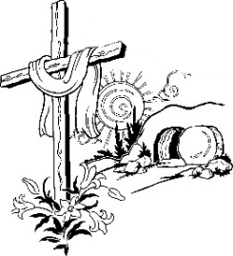](https://www.google.ca/url?sa=i&rct=j&q=&esrc=s&source=images&cd=&cad=rja&uact=8&ved=0ahUKEwiuqML1_YrTAhUI74MKHWK3BcgQjRwIBw&url=http://christchurchstroudsburg.net/weekly-schedule/holy-week-schedule/&bvm=bv.151426398,d.amc&psig=AFQjCNH9fkAbz-d1NRLXJAAgM4F0BRhZPw&ust=1491401054621968)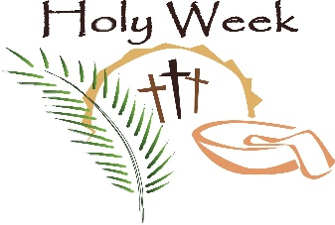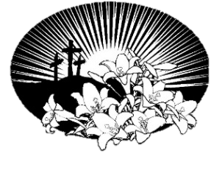[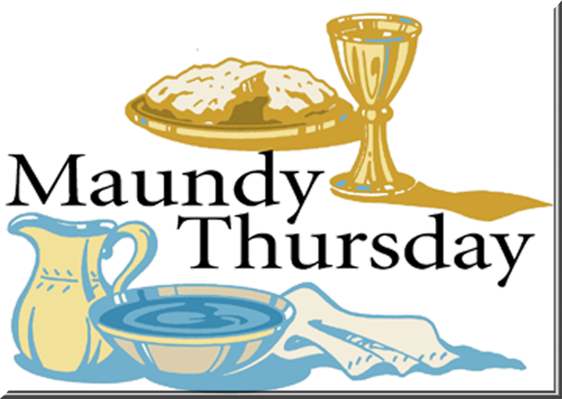](https://www.google.ca/url?sa=i&rct=j&q=&esrc=s&source=images&cd=&cad=rja&uact=8&ved=0ahUKEwjl4oeE-4rTAhUm6oMKHQ4ADF0QjRwIBw&url=https://clipartfest.com/categories/view/4f441cda1eca1b537eb8a2c58567e5937e559d35/holy-thursday-clipart.html&psig=AFQjCNHMd2dlgULPnz0oN8tBniEZmiAOjA&ust=1491400693898099)[](https://www.google.ca/url?sa=i&rct=j&q=&esrc=s&source=images&cd=&cad=rja&uact=8&ved=0ahUKEwif6o7PxPfSAhUG1oMKHeClB5wQjRwIBw&url=http://www.clipartvision.com/soup-and-sandwich-clipart-black-and-white/&bvm=bv.150729734,d.amc&psig=AFQjCNHr8mSZcn10h8polzuOtsgCL4l7lQ&ust=1490733339989550)

[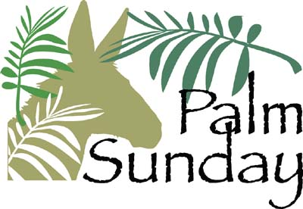](https://www.google.ca/url?sa=i&rct=j&q=&esrc=s&source=images&cd=&cad=rja&uact=8&ved=0ahUKEwjo9un7jozTAhVKw4MKHfsrDWQQjRwIBw&url=http://clipartix.com/palm-sunday-clipart/&bvm=bv.151426398,d.amc&psig=AFQjCNGlVgMds-0zPrdOhbie10STjrn0JQ&ust=1491440498713002)

**Pastoral Reflections**

**By Rev. Wilson Andrade, CSC**

***Hosanna in the Highest!*** A triumphant shout echoes only at the entrance of a great king. Waving of the green palm branches is for the victorious king who enters with glory! These both words and actions belonging only to the royalty are used by the people – for a humble man riding on a donkey.

***“Who is this King of Glory?”*** A man on a donkey! Did the people know already who is riding on a donkey! Or is it just a euphoria or excitement that comes along being in a crowd! Whatever may be the experience of the people – one experience is genuine – Jesus Christ.

Jesus was that person who brought that joy and elation to the people around him. But the euphoria of the crowd changes radically during the Passion play. It changes from singing ***“Hosanna”*** to ***“Crucify him”*** As it unfolds; the Way of joy and jubilation becomes the Way of the Cross. The Truth, remains in silence, as Jesus is condemned to die on the Cross. The Life drags on, struggles, nailed, hangs on the Cross.

All the Lenten readings were preparing us to meet this – man on a donkey. But He was not an ordinary man. It is only revealed when the centurion opens His heart on the Cross: ***“This man was truly the Son of God.”***

In the end the man on the donkey – dies on the cross, only to reveal the eternal mystery of our salvation – that Jesus who died on the Cross – is the Way, the Truth and the Life. The Cross becomes the symbol of God’s love and *‘everyone confess that Jesus Christ is the Lord.*’ Amen.