[](https://www.google.ca/url?sa=i&rct=j&q=&esrc=s&source=images&cd=&cad=rja&uact=8&ved=2ahUKEwjUrsG-pbfZAhWH3YMKHR70CNAQjRx6BAgAEAY&url=http://worldartsme.com/black-and-white-lent-clipart.html&psig=AOvVaw38tsi6jMZER8WPviFFZZSt&ust=1519312282174984)

**Mass Intentions**

**(February 23 – March 2, 2018)**

**Friday, February 23:** 7:00 p.m. Mass

**+ Godofredo Tolentino** *Req. Rosalie Tolentino*

**Holy Souls** *Req. Ena Francis*

**Monday, February 26:** 8:00 a.m. Mass

**+ Alberto Masongsong** *Req. Fe Santos*

**Wednesday, February 28:** 8:00 a.m. Mass

**Thanksgiving for Alexia Dunn** *Req. Toro Young & Dunn Family*

Please pray for the souls of parishioners **Jane Li**, **Michael Bower Jr**. and **Karolina Kowalewski**; and for consolation for their families at this time.

**Lenten Schedule**

**Fridays in Lent**

6:00 p.m. - Adoration

6:30 p.m. - Stations of the Cross

7:00 p.m. – Holy Eucharist

**Stations of the Cross schedule**

**Lenten Fridays Time: 6:30 - 7:00 p.m.**

March 2, 2018: Holy Cross Youth Movement

March 9, 2018: Parish Council

March 16, 2018: Holy Family Prayer

March 23, 2018: Development & Peace

March 30, 2018: Native Peoples Parish

[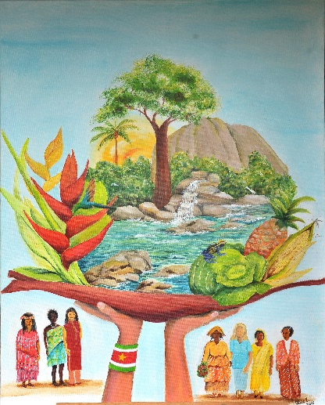](https://www.google.ca/url?sa=i&rct=j&q=&esrc=s&source=images&cd=&cad=rja&uact=8&ved=2ahUKEwi_kvmfwbfZAhWF3oMKHYDSDgQQjRx6BAgAEAY&url=https://wicc.org/world-day-of-prayer/how-to-participate/&psig=AOvVaw2guE5LmGNg9WF9Z5zSpHwB&ust=1519319703203281)

**2018 World Day of Prayer - Suriname**

This year, St. Ann Parish will be hosting the ecumenical Service for the 2018 World Day of Prayer. The focus will be on the South American country of Suriname, with the theme: *“All God’s Creation is Very Good”.* Join us **this** **Friday,** **March 2, 2018** at 2:00 p.m. to pray for peace and a greater care of creation. All are welcome.

The Republic of Suriname, named after the Surinem tribe, is part of the Guianas, an ecological region within the Amazon. Suriname is rich in natural resources, with a pristine tropical rain forest that covers 90% of the country, high biodiversity, and a warm and humid climate. 15% of its land surface is protected territory. In 1988, the National Institute for Environment and Development in Suriname was established to regulate and monitor the environmental activity in the nation.

However, as gold and crude oil provide foreign currency in Suriname, there is illegal mining. Their use of high-pressure hoses to dislodge sediment has transformed large areas of forest into craters and deserted landscapes, and their use of mercury has contaminated the water. Both fish and humans have high levels of mercury. Additionally, children’s attendance to school is not compulsory and there is no adult education or second-chance education for young people who drop out. Until 1948, women’s suffrage was not fully granted, and married women did not have the same civil rights as their spouses until 1981. But by ratifying an international convention on Elimination of All Forms of Discrimination against Women, and creating the National Bureau for Gender Policies and Domestic Violence, Suriname is set to strengthen the rights of women and combat domestic violence.

[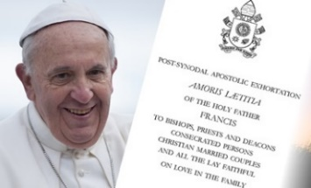](https://www.google.ca/url?sa=i&rct=j&q=&esrc=s&source=images&cd=&cad=rja&uact=8&ved=0ahUKEwj41NzI6PDYAhUp54MKHaedBKIQjRwIBw&url=http://nceatalk.org/2016/09/webinar-amoris-laetitia-listening-to-the-joys-and-hungers-of-families-part-1/&psig=AOvVaw3Iqy19Ca8fLQ9E3DFoK4SL&ust=1516890715891168)

**Fish and Chips**

St. Ann Parish is hosting Fish and Chips Fridays during Lent. Join us at the parish hall **every Friday of Lent**

**until March 30**, from 5:30 – 8:00 p.m. Suggested price: $5. Proceeds go towards the new Heating System project.

**Year of Ministry – February 2018**

During the month of February, please keep in your prayers and support our **Couples’ Ministry and Vocation Promotion**. Thank you for your time, talents and effective ministry at St. Ann parish and Native Peoples’ Mission. May God continue to bless you.

**Seminar on** **the Joy of Love:**

***Amoris Laetitia***

The Holy Family Prayer group is hosting a seminar on Pope Francis’ latest letter: ***The Joy of love Amoris Laetitia***. This is a special invitation for couples and families to register for the Sessions to be held on the **fourth Saturday of the month after the 5 p.m. Mass**

**Dates**: March 24 and

April 28

**Time**: 6:30 - 7:30 p.m.

**Place**: Parish Hall

For more information please contact the parish office

[](https://www.google.ca/url?sa=i&rct=j&q=&esrc=s&source=images&cd=&cad=rja&uact=8&ved=0ahUKEwjF1r3RzbXZAhXGz4MKHeBGAQcQjRwIBw&url=https://depositphotos.com/12427393/stock-illustration-plate-knife-and-fork.html&psig=AOvVaw2ZYPk4LgNZF9q03wYTRBj8&ust=1519254342358001)[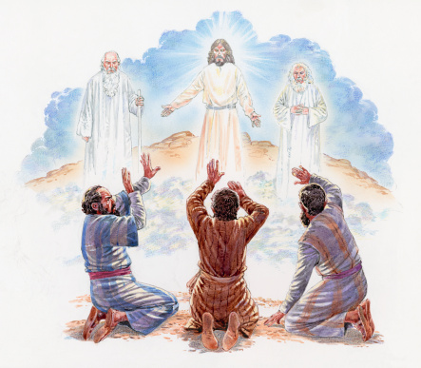](https://www.google.ca/url?sa=i&rct=j&q=&esrc=s&source=images&cd=&cad=rja&uact=8&ved=2ahUKEwjqjtWuy7fZAhUn6oMKHaRBDrYQjRx6BAgAEAY&url=http://www.greekboston.com/religion/transfiguration-lord-savior/&psig=AOvVaw14b6xXsdDaFUWbsPMJJeyi&ust=1519322441406718)

**Transfiguration**

**By Rev. Wilson Andrade, CSC**

We are in the second Sunday of Lent. Last Sunday we heard the story of the temptations of Jesus that conveyed the message of the humanity of Jesus. Today in the Gospel we heard the mountain-top experience of Jesus. This transfiguration event gives us the image of the divinity of Jesus. The liturgy invites us to reflect on the person of Jesus who is fully human and fully divine.

The two persons who appeared with Jesus, Moses and Elijah, proclaim that Jesus is the fulfillment of the promise of God to be the savior of the world. Here Moses, representing the Law of God (Pentateuch), and the Prophet

Elijah, representing prophetic literature, confirm that Jesus Christ is on a God-given mission to save the world. Witnessing the event, Peter says *“Master, it is good for us to be here… let us build tents to stay on this mountain top”* – prolonging the joyous and happy moment, whereas Jesus wants to go to Jerusalem to complete God’s mission on the mount of Calvary.

Today the liturgy invites us to be part of this awesome mystery of being in the presence of God. Every Eucharist is for us a mountain top experience of transfiguration where we are invited to change our old ways and begin anew with the help of God’s grace. We cannot *stay or build tents* in the liturgy, instead, we are called to “go the mass is ended and proclaim the Gospel.” Jesus invites us to complete the mission entrusted to us of being imitators of Christ, and, as the psalmist proclaims, to *“walk in the presence of the Lord, in the land of the living”.* (Ps. 116)

Let us be assured today that with Jesus Christ, we are God’s beloved Children, and that, as St. Paul says: *“Who will separate us from the love of Christ?”* (Romans 8.31b-35, 37)

**TAX Receipts for 2017**

Please do pick up your 2017 TAX Receipts at the Main Entrance of the Church. These are from your donations made to St. Ann parish only. Donations made to Family of Faith campaign are mailed directly to you. If you have any questions with the Tax Receipts please call the office or email us.

**Handmaids of the Lord**

**Sunday Breakfast**

**Join us today Sunday, February 25,** for the Handmaids of the Lord monthly Sunday Breakfast Please come down to the hall after the

10:30 a.m. mass and join us for a freshly made breakfast and fellowship.

**ShareLife**

Living the Gospel by supporting vocations…

“Living and studying at St. Augustine Seminary has brought untold blessings to my life,” shares Matthew Gunnarson, one of 80 seminarians undergoing formation at the joint campus of St. Augustine’s Seminary and Redemptoris Mater Seminary. He adds, “The seminary could not run without the generous support of ShareLife donors.” By supporting ShareLife, you are helping our future priests follow God’s call.

**St. Ann’s Parish Goal for 2018 is $7,000**

**March 18 is ShareLife Sunday. Please give generously.**