**ADVENT SEASON MASS SCHEDULE - 2017**

**Sunday, Dec. 24 Monday, Dec. 25 Saturday, Dec. 30 Sunday, Dec. 31, 2017**

**10:30 a.m.:** Advent Mass **10:30 a.m.:** Christmas **5:00 p.m.:** Feast of the **10:30 a.m.:** Feast of the

**12:30 p.m.:** Native Mass Mass Holy Family Mass Holy Family Mass

**2:30 p.m.**: Bridgepoint Mass **6:00 p.m.:** Family  **12:30 p.m.:** Native Mass

**3:30 p.m.:** Hospital Carols Potluck Fellowship **6:00 p.m.:** Family Mass

**7:00 p.m.:** Family Mass **6:00 p.m.:** NO Mass **11:00 p.m.:** Midnight mass

**9:00 p.m.:** Native Senior **11:30 p.m.:** Christmas carols **Monday, Jan. 1, 2018**

**12:00 a.m.:** Midnight mass **10:30 a.m.:** Thanksgiving Mass

**Second Sunday of Advent**

**Pastoral Reflections by Rev. Wilson Andrade, CSC**

As we light the second candle in the Advent Wreath, from the scriptures we are reminded the powerful call of St. John the Baptist: “**Prepare the Way of the Lord.”** We begin to prepare for Christmas the birth of our savoir, so let’s make a list for celebration, that we may not miss most important things in our celebration. When the world dazzles around selling the best products, ***let’s*** ***dare ourselves to silence and quiet prayers***. When the world bundles around the glowing packages, ***let’s take a brave step to unpack our souls*** – our sinful behaviours, our burdened hearts – so that ***“our paths are straight”*** for our Lord ***“to live among us.”*** This message is addressed in the Collect prayer saying ***“may no earthly undertaking hinder those who set out to meet Our Lord.”*** So this Sunday may be a time for us to prepare well to meet our Lord Jesus.

Let us not put any hindrance before our encounter with Jesus. When we encounter and experience the presence of Jesus then **Isaiah’s image of perfect living** becomes a reality. Everyone would live in harmony with each other like ‘wolf with lamb, leopard with kid, calf with lion.’ (Is. 11:8-9) This harmonious living is expressed in welcoming and respecting one another in Jesus Christ who came to proclaim ***“kingdom of God.”***

If we want to live in harmony within the kingdom of God then we listen to that Voice in the Desert: ***“Repent, for the Kingdom of Heaven has come near.”*** Let us prepare our hearts and minds so that we are ready to welcome Jesus in our hearts, into our homes, in our society and the world. Let us prepare ourselves to receive Jesus, Our saviour and Lord.

**Advent Reconciliation**

**Days of Individual Confessions**:

Dec. 10, Sunday Time: 9:00 a.m. to 8:00 p.m.

Dec. 12, Tuesday Time: 9:00 a.m. to 5:00 p.m.

Dec. 16, Saturday Time: 4:00 p.m. to 8:00 p.m.

**Day of Communal Reconciliation Preparation**:

Monday, Dec. 18 Time: 6:00 p.m. to 7:30 p.m.

**Christmas Collection for Resettlement Committee**

Our refugee family of four (a mother, father and two children) are living in Lebanon after fleeing conflict in their native Syria. The Resettlement Committee has worked with the Archdiocese, the local MP’s office and two very dedicated translators, to assist our family in completing their paperwork and preparing for their immigration interview. It’s anticipated the family will be arriving in September 2018. Your donation this holiday season will make a powerful difference to our refugee family who want to build a new life in Canada after facing the pain of war and displacement. Please use the yellow Humanitarian Relief Envelopes found at the back of the church for your donations towards this collection.

**Advent Adoration/Prayer**

Advent is a time for Prayer. We will have 9 Evening Masses before Christmas day, **from December 16th to December 24th**

**Please follow the Advent Schedule Handout**

**Mass Intentions**

**(December 8 – December 15, 2017)**

**Friday, December 8:** *The Immaculate Conception of the Blessed Virgin Mary*

**7:00 p.m.:+Therese Wong** Req. Agnes Lam

**Thanksgiving** Req. Mary Chen

**Intentions of Paola Loduca** Req. Paolo Loduca

**Saturday, December 9:**

**5:00 p.m: + Remejo Millare Req. Virgie Sison**

**Thanksgiving** Req. Mary Chen

**Sunday, December 10:**

**6:00 p.m.: + Kathryn A. Loures** Req. Helen Cuneo

**+ Frank Sehovic, Ivanka & Leo Gorse** Req. Mary Sehovic

**Monday, December 11:** *St. Damasus I*

**8:00 a.m.: Intentions of Mary Chen** Req. Mary Chen

**Thanksgiving** Req. Jiang Yuming

**Tuesday, December 12:** *Our Lady of Guadalupe*

**8:00 a.m.:+ Yan Qin Chen** Req. Wang Zhu Mei

**Intentions of Anna & Onofrio** Req. Paolo Loduca

**Wednesday, December 13:** *St. Lucy*

**8:00 a.m.: +Ren Jie Chen** Req. Wang Zhu Mei

**Intentions of Mary Chen** Req. Mary Chen

**Thursday, December 14:** *St. John of the Cross*

**8:00 a.m.: Intentions of Paolo Palma & Fransca Paolo** Req. Paolo Loduca

**Friday, December 15:**

**7:00 p.m.: Intentions of Mary Chen** Req. Mary Chen

**Intentions of Francesco & Teresa Stina** Req. Paolo Loduca

**Thanksgiving for Ann Dunn** Req. Dunn & Toro Family

## 2017 National Day of Prayer in Solidarity with Indigenous Peoples

The National Day of Prayer in Solidarity with Indigenous Peoples has been celebrated since 2002 on **December 12** by the Church in Canada**.** On this date, let us join the Aboriginal People of the Americas to pray for greater solidarity among us, and together, to bring peace to the Americas.

**Major Fundraiser Activity**

After the consultation with the Finance Council, we will begin our Major Fundraiser Activity and will be distributing Donation envelops to the members of the parish. There is a letter of Request for Donation and pledge card. Please do take one. You are welcome to give it to those whom you think could be potential donors to support our Fund Raising Activities.

**Christmas Ornament**

Help decorate the church by purchasing a Christmas ornament and placing it on our Christmas tree. Ornaments are $5 and being sold at the front entrance.

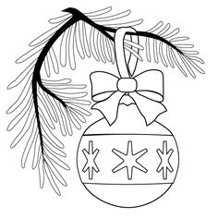

**Envelopes for 2018**

Envelopes for 2018 are now available at the back of the church. If you would like an envelope box, or to contribute through P.A.G., please fill out and submit the respective form. Those who have given the form for Envelopes, can now receive them at the entrance.

**Thank you, Deacon Roshan Kiro, SJ**

We would like to thank Deacon Roshan Kiro, SJ, for his ministry at St. Ann Parish. He will be travelling to India and will be ordained to priesthood on **December 28, 2017**. Please continue to

support him with your prayers. Best wishes.

**Development & Peace: *Thank you!***

On behalf of all women who build peace in their communities, Development and Peace – Caritas Canada thanks you for your continued commitment. At our parish, we

raised $250 towards the Rohingya Refugee Crisis and the Government has committed to match this donation. Together, we have the power to change things! For more information on D&P work, please go to devp.org/membership.

[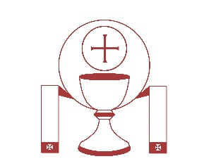](https://www.google.ca/url?sa=i&rct=j&q=&esrc=s&source=images&cd=&cad=rja&uact=8&ved=0ahUKEwjX7efFzvXXAhWkT98KHY2iDS4QjRwIBw&url=https://listenmyson.wordpress.com/tag/ordination/&psig=AOvVaw06_K6cJd8d0jd2NTgNvmh2&ust=1512657502051960)[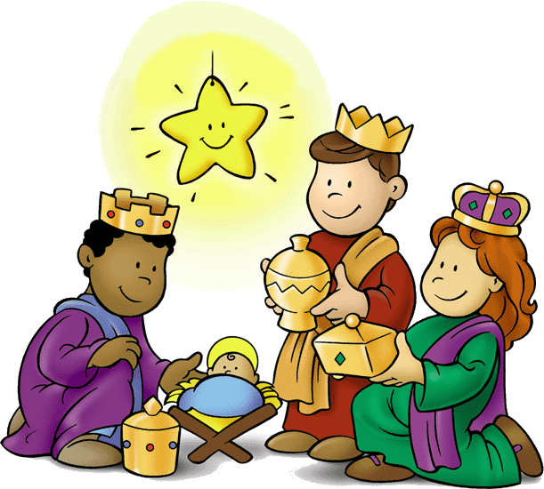](https://www.google.ca/url?sa=i&rct=j&q=&esrc=s&source=images&cd=&cad=rja&uact=8&ved=&url=http://eastchurchucc.org/event/christmas-pageant-2016&psig=AOvVaw2PI5sJ_xxT65sNfpwMytZj&ust=1508938450045169)

**Children’s Christmas pageant**

Rehearsals will continue every Sunday until Christmas Eve. For more info, email Nancy and Melody McMullan at melody.mcmullan@ryerson.ca

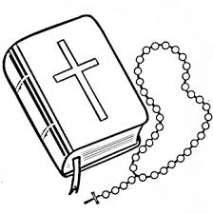[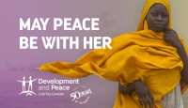](https://www.google.ca/url?sa=i&rct=j&q=&esrc=s&source=images&cd=&cad=rja&uact=8&ved=0ahUKEwiYidPWnpvXAhUH64MKHSSEA7IQjRwIBw&url=https://www.devp.org/en/education/fall2017/news&psig=AOvVaw1c-ZVtebZq7dKq1CbCfxqV&ust=1509552274594109)

**Christmas Donations to the poor**

There are a number of items that are displayed at the entrance of the Church. Donations made from these items will be used to help the poor with food and clothing during the winter season.

* 2018 Calendars: $1.00
* New Missals: $ 5.00
* Family Prayer Book: $ 5.00
* Christmas Ornaments: $ 2.00

Envelops will be distributed to buy the flowers and liturgical items to make a beautiful Christmas Crib and decorate the Altar.