**Mass Intentions**

**(May 11 – May 18, 2018)**

**Friday, May 11:** 7:00 p.m. Mass

**+ Christine Fernandes** *Req. Maria Fernandes*

**+ Victoria Ortiz** *Req. Nancy Ong Nilda Ortiz*

**Saturday, May 12:** 5:00 p.m. Mass

**+ Christine Fernandes** *Req. Maria Fernandes*

**Tuesday, May 15:** 8:00 a.m. Mass

**+ Maria Lourdes Altarejos** *Req. Connie Altarejos*

**Thursday, May 17:** 8:00 a.m. Mass

**Thanksgiving for Leon Victor Aureus** *Req. Mavic Galicia*

**Thursday, May 10:** 8:00 a.m. Mass

**+Lilibeth Abbagutelan**

**Year of Ministry – May 2018**

During the month of May, we pray for all the women who minister in the Church. We pray and support all the women who are in various ministries. We also remember and pray for all the Mothers who work hard to build up families. We also support and pray for the Handmaids of the Lord group, who minister in our Parish, and everyone who has a special devotion to Mary our Mother. Thank you for your time, talents and effective ministry at St. Ann parish and Native Peoples’ Mission. May God continue to bless you.

**ShareLife 2018**

**Living the Gospel by supporting mental health wellness.** In 2016, over 2,000 people accessed individual, couple and family counselling at Catholic Family Services of PeelDuferin, a ShareLife-funded agency. Often, clients sought help to address depression. Given that depression has replaced back injury as the number one reason for absenteeism at work, these services are helping clients maintain employment and stay out of poverty. By supporting ShareLife agencies like CFS Peel-Duferin, you’re helping people fnd health and happiness.

**May 27 is the next ShareLife Sunday.**

**Please give generously.**

**Provincial Chapter Meeting of**

**the Congregation of Holy Cross**

Fr. Wilson Andrade will be away in India from May 14 to May 31, 2018. He will be attending the Provincial Chapter of Holy Cross and holidays in India. We wish him all the best and safe travels. Please pray for the Chapter Meeting, where important decisions are taken for the Holy Cross Fathers. Fr. Francis Noronha and Fr. Roshan Kiro, SJ will be available for Pastoral needs.

**Refugee Resettlement Committee Meeting**

St. Ann’s Resettlement Committee will be holding their monthly Committee meeting on **Sunday, May 27** after the 10:30 a.m. mass, in the church rectory. Committee members are encouraged to attend and new members are always welcomed to join. If you have any questions please contact Theresa at 416-700-3358 or theresaspohn@gmail.com

**Thanksgiving Mass for**

**the Feast of Corpus Christi**

**Come and join us on June 3** at St. Michael's Cathedral, (65 Bond St., Toronto) as we celebrate the feast of Corpus Christi along with Zone 1 and Zone 2 Parishes. Mass will be celebrated at 2:00 p.m., presided by Bishop Robert Kasun, CSB. All are welcome to attend. For more information, please contact any of the following parishes: St. Ann Parish at 416-466-2127; St. Brigid's Parish at 416-696-8660; or St. Michael's Cathedral at 416-364-0234

**Thank you!**

A heartfelt thank you to all who contributed towards the launching of the Holy Cross Family Ministries in Canada. Our celebration of Family Prayer on May 5, couldn’t have been possible without the support of the community. Many blessings to you and your families.

**Summer Schedule for**

**Eucharistic Ministers and Lectors**

We are currently in the process of scheduling the Eucharistic Ministers and Lectors for the Summer time. Should you be away during summer, please let us know the dates as to plan accordingly. You

can call the office at 416-466-2127 or fill out the form on the information table at the back of the church.



**Church Bulletin Advertising**

Liturgical Publications will be setting up the advertisements for our church bulletin. The advertising will begin in July 2018 and supports the bulletin service. Please support the bulletin and advertise your product or service. Call Liturgical Publications at 905-624-4422.

**Ascension of the Lord**

**Pastoral Reflections**

**By: Rev. Wilson Andrade, CSC**

Today we celebrate the feast of the Ascension of Our Lord. This feast signifies a great handing over of the mission of Christ Jesus, who called us “his friends” and gave us the final command to continue to proclaim his message of Love. *“Go, therefore, and make disciples of all nations, baptizing them in the name of the Father, and of the Son, and of the Holy Spirit, teaching them to observe all that I have commanded you. And behold, I am with you always, until the end of the age.”*

Jesus called us friends so we are to live in the friendship with God and one another. Today we Christians are called to proclaim the Gospel. One of the most significant gestures of making friends is expressed by Pope Francis who went to visit the Holy Land, embraced and dialogued with the other faiths and beliefs. How can we in our own way proclaim the Gospel of Christ with our next door neighbors? We in our Baptism have received this call to proclaim the Gospel – to make everyone Disciples of Christ – friends of God. How do we respond to this last and greatest commandment of Christ our Savior?

Let every Eucharist may be a time for us reflect on our call to proclaim the Gospel of Christ to our family, friends, neighbors, and those who find life difficult? The promise of Jesus is very clear: “I am with you always” so courageously proclaim the Gospel of Christ and make every Disciples of Christ and friends of God.

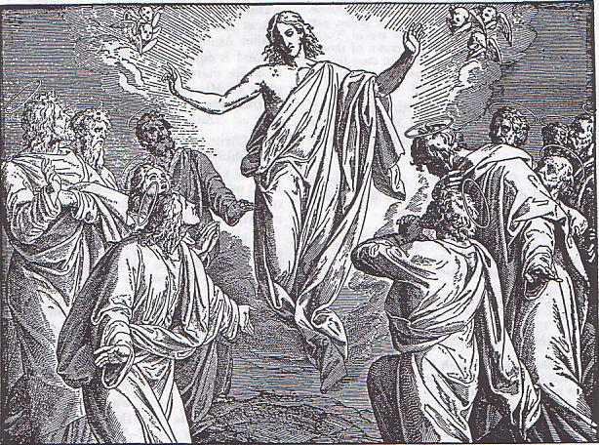

[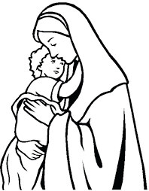](https://www.google.ca/url?sa=i&rct=j&q=&esrc=s&source=images&cd=&cad=rja&uact=8&ved=2ahUKEwjs-Kq9uvTaAhUn6oMKHZBmCoMQjRx6BAgBEAU&url=http://usedauto.club/free-blessed-mother-coloring-pages/free-blessed-mother-coloring-pages-mom-you-are-great-mothers-day-coloring-page-for-kids-coloring-pages-free-coloring-pages-flowers-in-a-vase/&psig=AOvVaw0pZZdCDzmLhhjmP1TMLSZB&ust=1525811910661106)

**Pilgrimage to Quebec Shrines - 4 Days, 3 Nights**

Holy Cross Family Ministries invites you to join us on a Pilgrimage to Quebec Shrines from **August 3-6.** Visit St. Anne de Beaupre, Cap de Madeleine, St. Joseph Oratory and Quebec City, with time for personal prayer and spiritual activities. Departure from St. Ann Church on Friday, August 3 at 7:00 a.m. Price: $500.00 pp (includes travel and lodging). Pilgrims are responsible for meals, out of province insurance, spending money and personal belongings. A non-refundable deposit of $150.00 is required by July 1st. For more information, please contact Maria Fernandes at 416 469 5277.

***Happy Mother’s Day***

On behalf of St. Ann Parish and Native Peoples’ Mission, we wish all mothers a Happy Mother’s Day.

*The most important person on earth is a mother. She cannot claim the honour of having built Notre Dame Cathedral. She need not. She has built something more magnificent than any cathedral—a dwelling for an immortal soul, the tiny perfection of her baby’s body. The angels have not been blessed with such a grace. They cannot share in God’s creative miracle to bring new saints to Heaven. Only a human mother can. Mothers are closer to God the Creator than any other creature; God joins forces with mothers in performing this act of creation. . . What on God’s good earth is more glorious than this; to be a mother?* ***-Joszef Cardinal Mindszenty***