**The Year of Ministry**

“Many Ministries for one mission of Jesus Christ” (Cf. 1 Cor. 12)

We, the community of St. Ann and Native Peoples’ Mission will celebrate the liturgical year of 2017 – 2018 as the YEAR OF MINISTRY. This Annual theme follows The Year of Mercy - 2015 – 2016 (proclaimed by Pope Francis) then the last year we celebrated The Year of The Family. It was a meaningful way to celebrate the Mercy of God in our families, communities, and society recognising various events in our family life.

During the Year of Ministry we will focus on the various ministries we are entrusted in our church community. We will celebrate each ministry, encouraging everyone to actively participate in ministries of the Church and to reflect on their gifts. With 30 different ministries at St. Ann and Native Peoples’ Mission, we will focus on the Three Cardinal Virtues of Faith, Hope and Charity that are at the heart of our ministries. Let’s encourage one another in serving God and the people of God, bearing witness to God’s love by establishing the community of LOVE, proclaiming and celebrating our FAITH and Communicating HOPE to all the creation.

**The Community of LOVE**

“God is love.” Charity is love in action. Let love be focus our ministry and foundation of every task we do. During this year we build the community of love through our prayers and liturgies, conversations and discussions and in every action we do. Let our personal life, family life, social life, Church life be a places of doing acts of Charity. Taking the example from Jesus, let’s be messengers and witnesses of God’s love.

**The Celebration of FAITH**

We can do acts of Charity with the deep Faith we have in God’s love. Let our service be rooted in faith. We believe God has called to be ministers to celebrate God’s love with one another. Faith fills us with the grace to move forward when we are tired, discouraged, and burnout. With the Celebration of our faith with prayers and encouragement, we become active servants of God and community.

**The Communication of HOPE**

Hope motivates us in our ministries. We are called to minster and bring hope to those who need it the most. With our service let’s communicate Hope to the world. Every ministry is a moment of sharing of God’s hope for everyone. We welcome everyone to be part of community where we proclaim Jesus Christ: the Hope, the Resurrection and the Life.

We celebrate our Year of Ministry receiving the grace, motivation and inspiration from the Holy Family of Jesus, Mary and Joseph, together with Sts. Ann and Joachim who is our Patron and grandparents of Jesus. Let’s celebrate our many ministries and our Christian Faith in Jesus Christ, Our Lord. May God bless every ministry we do in our Community of **LOVE** – celebrating our **FAITH** and communicating **HOPE** to everyone. Amen.

***Do not forget to smile.*** Fr. Wilson Andrade, CSC

|  |  |  |
| --- | --- | --- |
| **Community of Love** | **Celebration of Faith** | **Communication of Hope** |
| **Pastoral Staff Members** | **Liturgy/Faith Formation** | **Food Bank** |
| **Vocation Committee** | **Lectors** | **Development and Peace** |
| **Pastoral Council** | **Eucharistic Ministers** | **Refugee Resettlement Group** |
| **Finance Council** | **Holy Family Prayer Group** | **Grief Ministry** |
| **Seniors’ Group** | **Handmaids of the Lord** | **Volunteer Screening Group** |
| **Bridgepoint Hospital** | **Music Ministry** | **AA group & Girl Guides** |
| **Holy Cross Youth Group** | **Children’s Liturgy Ministry** | **Collection Counters** |
| **Hospitality committee** | **Novena Devotions Group** | **Adult English Learning** |
| **Couples Ministry** | **Altar Servers** | **Mission Work** |
| **Native Spiritual Tradition - Education** | **Pilgrimages** | **Tai Chi** |

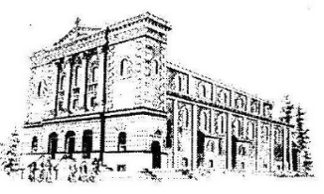[](https://www.google.ca/url?sa=i&rct=j&q=&esrc=s&source=images&cd=&cad=rja&uact=8&ved=0ahUKEwjVr-Kyz_XWAhVX1WMKHd_3BGAQjRwIBw&url=https://www.unityns.org/christmas-gala-2012&psig=AOvVaw16O_jVl1oJ74UaL9JwcdSK&ust=1508259585675234)

St. Ann’s Parish invites you to celebrate with us this Christmas season with a Christmas Gala Evening on **Saturday,** **December 9**. The formal reception will be held in the Hall starting at 6:30 p.m. Tickets are $30.00 with proceeds going towards the New Heating System.

**Mass Intentions**

**(Decemeber 1 – December 7, 2017)**

**Friday, December 1:**

**7:00 p.m.: +Remejo Millare** Req. Virgie Sison

**+Mita Hapal** Req. Masongsong & Santos Family

**Saturday, December 2:** *St. Catherine of Alexandria*

**5:00 p.m.:+Fr. John Campbell** Req. Maria Fernandes

**+ Sould of the Sehovic Family** Req. Mary Sehovic

**Sunday, December 3:**

**6:00 p.m.: + Therese Wong**

Req. Agnes Lam, Alan & Vicki Wong

**+Mr. & Mrs. Domnic D’Souza** Req. Maria Fernandes

**Thanksgiving for Connie Altarejos-Lee**

Req. Connie Altarejos-Lee

**Monday, December 4:** *St. John Damascene*

**8:00 a.m.: + Remejo Millare** Req. Virgie Sison

**+ Mr. Lawrence Rodrigues** Req. Maria Fernandes

**Tuesday, December 5:**

**8:00 a.m.:+ Piedad Fernandes** Req. Maria Fernandes

**Thanksgiving for Jiang Yuming** Req. Jiang Yuming

**Wednesday, December 6:** *St. Nicholas*

**8:00 a.m.: +Gabru Dieas** Req. Maria Fernandes

**Thanksgiving for Jiang Yuming** Req. Jiang Yuming

**Thursday, December 7:** *St. Ambrose*

**8:00 a.m.: + Therese Wong** Req. Agnes Lam

**+ Opu Dieas** Req. Maria Fernandes

**Friday, December 8:** *The Immaculate Conception of the Blessed Virgin Mary*

**7:00 p.m.:+Therese Wong** Req. Agnes Lam

**Thanksgiving for Mary Chen’s children**

Req. Mary Chen

**Intentions of Paola Loduca** Req. Paolo Loduca

**Major Fundraiser Activity**

After the consultation with the Finance Council, we will begin our Major Fundraiser Activity and will be distributing Donation envelops to the members of the parish. There is a letter of Request for Donation and pledge card. Please do take one. You are welcome to give it to those whom you think could be potential donors to support our Fund Raising Activities.

**Envelopes for 2018**

We have begun to distribute the envelopes for 2018 at the back of the church. If you would like an envelope box, or to contribute through P.A.G., please fill out and submit the respective form before December 10, 2017.

Those who have given the form for Envelops, can now receive them at the entrance.

[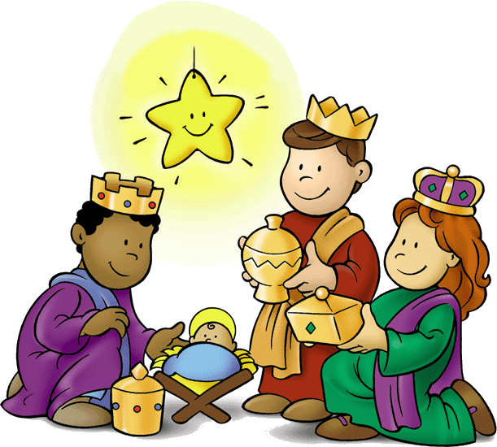](https://www.google.ca/url?sa=i&rct=j&q=&esrc=s&source=images&cd=&cad=rja&uact=8&ved=&url=http://eastchurchucc.org/event/christmas-pageant-2016&psig=AOvVaw2PI5sJ_xxT65sNfpwMytZj&ust=1508938450045169)

[](https://www.google.ca/url?sa=i&rct=j&q=&esrc=s&source=images&cd=&cad=rja&uact=8&ved=0ahUKEwiYidPWnpvXAhUH64MKHSSEA7IQjRwIBw&url=https://www.devp.org/en/education/fall2017/news&psig=AOvVaw1c-ZVtebZq7dKq1CbCfxqV&ust=1509552274594109)

**Christmas Donations to the poor**

There are a number of items that are displayed at the entrance of the Church. Donations made from these items will be used to help the poor with food and clothing during the winter season.

* 2018 Calendars: $1.00
* New Missals: $ 5.00
* Family Prayer Book: $ 5.00
* Christmas Ornaments: $ 2.00

Envelops will be distributed to buy the flowers and liturgical items to make a beautiful Christmas Crib and decorate the Altar.



**Development & Peace: *May Peace Be With Her***

Did you know that only 2% of international funding dedicated to peace and security is allocated to equality between women and men or the empowerment of

women? “For me, peace is being able to touch the hearts of people around us. It is the ability to explain what is within us so that others understand. It is being able to influence others in a positive way.”

(Rabia Kadiry, House of Peace, Lebanon)

**Children’s Christmas pageant**

Rehearsals for the children’s Christmas pageant **continue today Sunday after the morning mass.** If you have any questions, or would like to sign up, feel free to contact Melody or Nancy

McMullan or email melody.mcmullan@ryerson.ca