**Holy Cross Family Ministries: Celebrating Family Prayer**

*“Family that Prays together, stays together.”*

Ven. Patrick Peyton, CSC

Join us to celebrate Family Prayer on **Saturday, May 5,** **2018** hosted by the Holy Cross Family Ministries.

**4:00 p.m.** – **Marian Procession and Rosary**

**5:00 p.m**. - **Holy Eucharist** celebrated by Archbishop James MacDonald, CSC

**6:00 p.m.** - **Dinner & Dance**

Dinner and Dance Tickets are available at $15.00 at the back of the church. Proceeds will go towards supporting the Holy Cross Family Ministries in Canada. Please, continue to support as begin the Family ministry in Canada.

**Mass Intentions**

**(March 30 – April 6, 2018)**

**Thursday, April 5:** 8:00 a.m. Mass

**Healing of Virginia Sampang** *Req. Edel Sampang-Gomes*

**Friday, April 6:** 7:00 p.m. Mass

**Intentions of Marietta Bier** *Req. Marietta Bier*

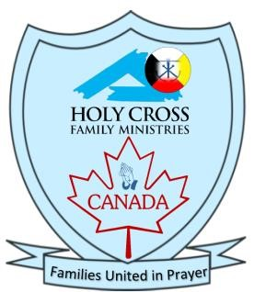

**ShareLife 2018**

**Living the Gospel by evangelizing our faith in the greater world.** Gia Lao Parish resides in the mountainous Diocese of Xuan Loc in Vietnam. Its parishioners, mostly poor, work on the hillside farms. With the support of ShareLife, the Pastoral Mission Fund provided a one-time grant so the parish could acquire resources it could not otherwise provide. This includes bibles and hymnals, along with training for 60 catechists, who lead marriage preparation and catechism classes. With your support, Gia Lao Church is bringing faith to a community in the greater world. **April 22 is the next ShareLife Sunday.**

**Please give generously.**

**Year of Ministry – April 2018**

During the month of April, as we celebrate the resurrection of Jesus Christ, who invites us to proclaim the Good News of our Salvation, we pray and support our **Ministers of the Word** (Lectors), the Ministers of **Holy Communion**, **Ushers** and the Ministers of the **Hospitality**.

If you would like to be part of any of these ministries, I ask you connect the office or fill out the form available at the entrance.

I also encourage those who serving in these ministries to attend an information session on Accessibility for Ontarians with Disabilities Act to be held on April 29th, 2018 Sunday after the morning 10:30 am mass.

Thank you for your time, talents and effective ministry at St. Ann parish and Native Peoples’ Mission. May God continue to bless you.

**Easter Retreat with Fr. Jacques Philippe**

Join Newman Centre (89 St. George St. Toronto), on April 14, for an Easter Retreat on *The Eight Doors of the Kingdom.* We are blessed to have Fr. Jacques guide our community on the importance of living the Beatitudes. Staring at 9:00 am, Fr. Jacques Philippe shows how true joy comes from spiritual poverty lived according to the Gospel in this retreat. Father will give examples from the Scriptures to teach us what it means to be spiritually poor before God, ourselves, and our brothers and sisters.

**Seminar on** **the Joy of Love: *Amoris Laetitia***

The Holy Family Prayer group is hosting a seminar on Pope Francis’ latest letter: ***The Joy of love Amoris Laetitia***. This is a special invitation for couples and families to register

for the Sessions held on the fourth Saturday of the month after the 5 p.m. Mass. **Our last session will be on April 28, from 6:30 - 7:30 p.m., at the Hall.** For more information please contact the parish office.

[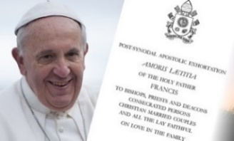](https://www.google.ca/url?sa=i&rct=j&q=&esrc=s&source=images&cd=&cad=rja&uact=8&ved=0ahUKEwj41NzI6PDYAhUp54MKHaedBKIQjRwIBw&url=http://nceatalk.org/2016/09/webinar-amoris-laetitia-listening-to-the-joys-and-hungers-of-families-part-1/&psig=AOvVaw3Iqy19Ca8fLQ9E3DFoK4SL&ust=1516890715891168)

**TAX Receipts for 2017**

Please do pick up your 2017 Tax Receipts at the Main Entrance of the Church. These are from your donations made to St. Ann parish only. Donations made to Family of Faith campaign are mailed directly to you. If you have questions regarding the Tax Receipts please call the office or email us.

[](http://www.google.ca/url?sa=i&rct=j&q=&esrc=s&source=images&cd=&cad=rja&uact=8&ved=0ahUKEwio_-ertubLAhWCuoMKHWpFAgkQjRwIBw&url=http://www.dreamstime.com/stock-illustration-bless-home-embroidery-wood-frame-retro-cross-stitch-design-needlework-house-blue-background-mat-square-dark-white-image51685627&bvm=bv.118353311,d.amc&psig=AFQjCNFo-bE9blAifuKlNvyUqVyV7-bgew&ust=1459359071089806)

**House Blessing**

If anyone would like the Priest to visit and bless your homes throughout the year, please let us know. You can call the Parish office at 416-466-2127 to set up an appointment to bless your homes.

.

**Pastoral Reflections**

**By Rev. Wilson Andrade, CSC**

Dear Friends,

Once again we joyfully celebrate the glorious Resurrection of our Lord Jesus Christ. This is the day when Jesus conquered death and gave us life. This is the day when Jesus conquered fear and gave us freedom. It is the greatest and the most solemn feast in the Church. It is the feast of Jesus transforming us and making us a new creation.

*Easter holds out an invitation to each one of us. It invites us to open our hearts to the risen Jesus and to let him do for us what he did for the disciples, that is to offer peace and joy. It invites us to let Jesus help us trust once again, after we have had our trust betrayed. It invites us to let Jesus help us to love again. It invites us to have hope. It invites us to start all over again. This is what Easter is all about. It’s the good news that the risen Jesus is in our midst. It’s the good news that Jesus has triumphed over evil and death. It is the good news that Jesus is ready to work miracles for us.*

As we celebrate Easter let us reflect on the words of Pope Francis, *“Dear brothers and sisters, Let the risen Jesus enter your life, welcome him as a friend, with trust: he is life! If until now you have kept him at a distance, step forward. Jesus will receive you with open arms. If you have been indifferent, take a risk: you won’t be disappointed. If following Jesus seems difficult, don’t be afraid, trust him, be confident that he is close to you, he is with you and he will give you the peace you are looking for and the strength to live as he would have you do”.*

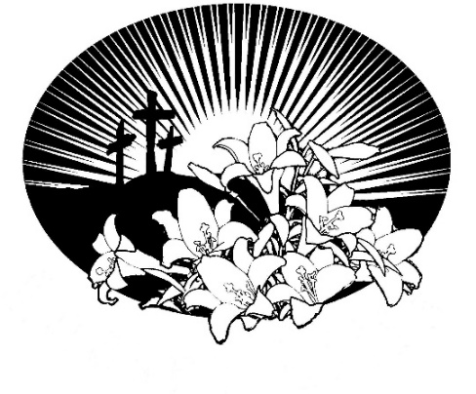

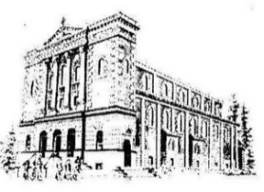[](http://www.google.ca/url?sa=i&rct=j&q=&esrc=s&source=images&cd=&cad=rja&uact=8&ved=0ahUKEwiO6JqB8YHNAhUNRVIKHWASDcwQjRwIBw&url=http://www.clipartpanda.com/clipart_images/fume-cup-of-coffee-22785138&bvm=bv.123325700,d.aXo&psig=AFQjCNHv83TUCOHKdRf5nIV3xVLt3lqIBA&ust=1464700575876372)

**Development and Peace Coffee Sunday.**

Next Sunday, **April 8**, Development and Peace will have Fair Trade Products (tea, coffee, cocoa and chocolate) for sale after the 10:30 a.m. mass at the back of the church. You are also encouraged to become a D&P member, a great way to educate yourself about social justice issues.

*TOGETHER FOR PEACE.*

**Theology of the Body Certificate Series with Sr. Helena Burns, FSP.**

Place: Sadleir House 751 George St. N.

**Dates: Saturday, March 17, April 7, 14, 21, May 5, 12.** Using JPII's original and dynamic synthesis, Sister Helena will help students unpack God's story of love, sex, the body, beauty and relationships. Students will be given the tools to grasp and explain controversial Church teachings, especially regarding personhood and sexuality. Also available online.

Price: $ 75.00. **Phone:** 705-745-5549

www.sacredheartcollege.ca **Email.**registrar@sacredheartcollege.ca

**Thanks for celebrating Easter**

We would like to thank everyone who helped to make our celebrations more beautiful, meaningful and richer especially: Choir members, Altar servers, Eucharist ministers, Lectors, Decorators, sacristans, Handmaids

of the Lord, Holy Family Prayer Group, Holy Cross Youth, Food Bank volunteers, Development and Peace Committee members. Thank you for your time and commitment. We also extend our Easter wishes to every member of our parish. Thank you for everything you are to us and for the blessing you all bring to our Parish Community of St. and Native Peoples’ Mission. May you and your families filled with Easter Joy.